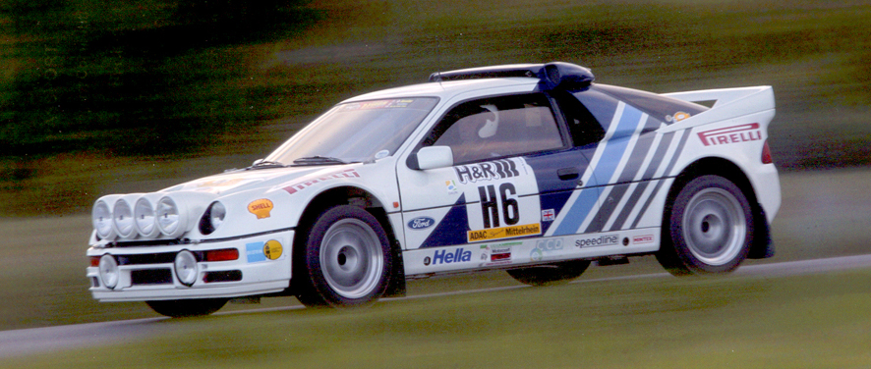

FORD RS200, 1986. (Left Hand Drive)

Chassis-number : SFACXXBJ2CGL00185.
Registration : C200 RAN.

According to the present owner of this car it was one of the cars of the original batch manufactured in 1986.
Released by Ford in 1989 it spent the first years of its life as a road-car/Demo vehicle.

The present owner bought the car in 1999 and it came with the engine in 475 BHP trim.
He then had it prepared according to the new UK rules for Special Stage Rallies.
These rules required all modern safety features and restriction of the power at 350 BHP at the flywheel according to WRC specifications.
In March 2000 permission was granted by the MSA to take part with this car in events forming the ACSMC/ASEMC 2000 Stage Rally Championship.
For this the car had to be inspected by the MSA technical inspector and accordingly a Stage Rally Vehicle Identity Form was issued by the MSA in April 2000.

The owner then entered this car a.o. in the following events:

2000 West Essex Rally Sprint, UK.
2000 Longcross Rally, UK.
2001 Goodwood Rally Sprint, UK.
2001 2 rounds of the UK Tarmac Championship, UK.
2001 Ringmeister Rally, Germany.
2002 Montburgh Rally Sprint, Belgium.
2002 Rally of the Lakes, Ireland.
2003 Balleares Rally, Mallorca-Spain.
2003 Eifel Rally, Germany.
2004 Deutschland WRC Rally, Germany.
2005 Eifel Rally, Germany.

Presently the full specifications of this car include a Step-3 1999cc engine that is capable of 475 BHP (without restrictor and with the correct ECU computer to suit).
It has 330 mm brakes, power steering, adjustable roll bars, adjustable rate dampers and full kevlar underbody protection.

In the years in which the owner has campaigned this car he has assembled an impressive batch of important and rare spare-parts for this car.

This batch of parts is included with the car, and it contains a.o. the following parts:

- 1 new un-used engine, complete with sump and oil-pumps.
- 1 new engine-block.
- 1 new cylinder-head
- 1 new turbo + parts.
- 1 air-filter
- 1 complete gearbox with central and front differential (serviced).
- 1 new gearbox
- 1 new front differential
- 1 crank-shaft
- 1 exhaust silencer
- used pistons and conrods
- suspension uprights
- various drive-shafts
- various used shock absorbers
- 1 front beam-unit.
- 1 front lower spoiler
- 24+ rims, most fitted with tyres ( slicks, FIA dry cut slicks, wets).
- miscellaneous small parts.

Now the owner has the purchase of another type of car in mind and has decided to put
this RS200 for sale.
This car is not a showroom model but a car that is ready for serious competition.
Since the last engine rebuild the car has participated in 5 events and today it still is in a very good mechanical condition.
It will take only an overall check and service in order to enter it for a next event, such as the 2006 Eifel Rally for instance.

The car, including all spares, is priced at : 85.000,-- GBP.



